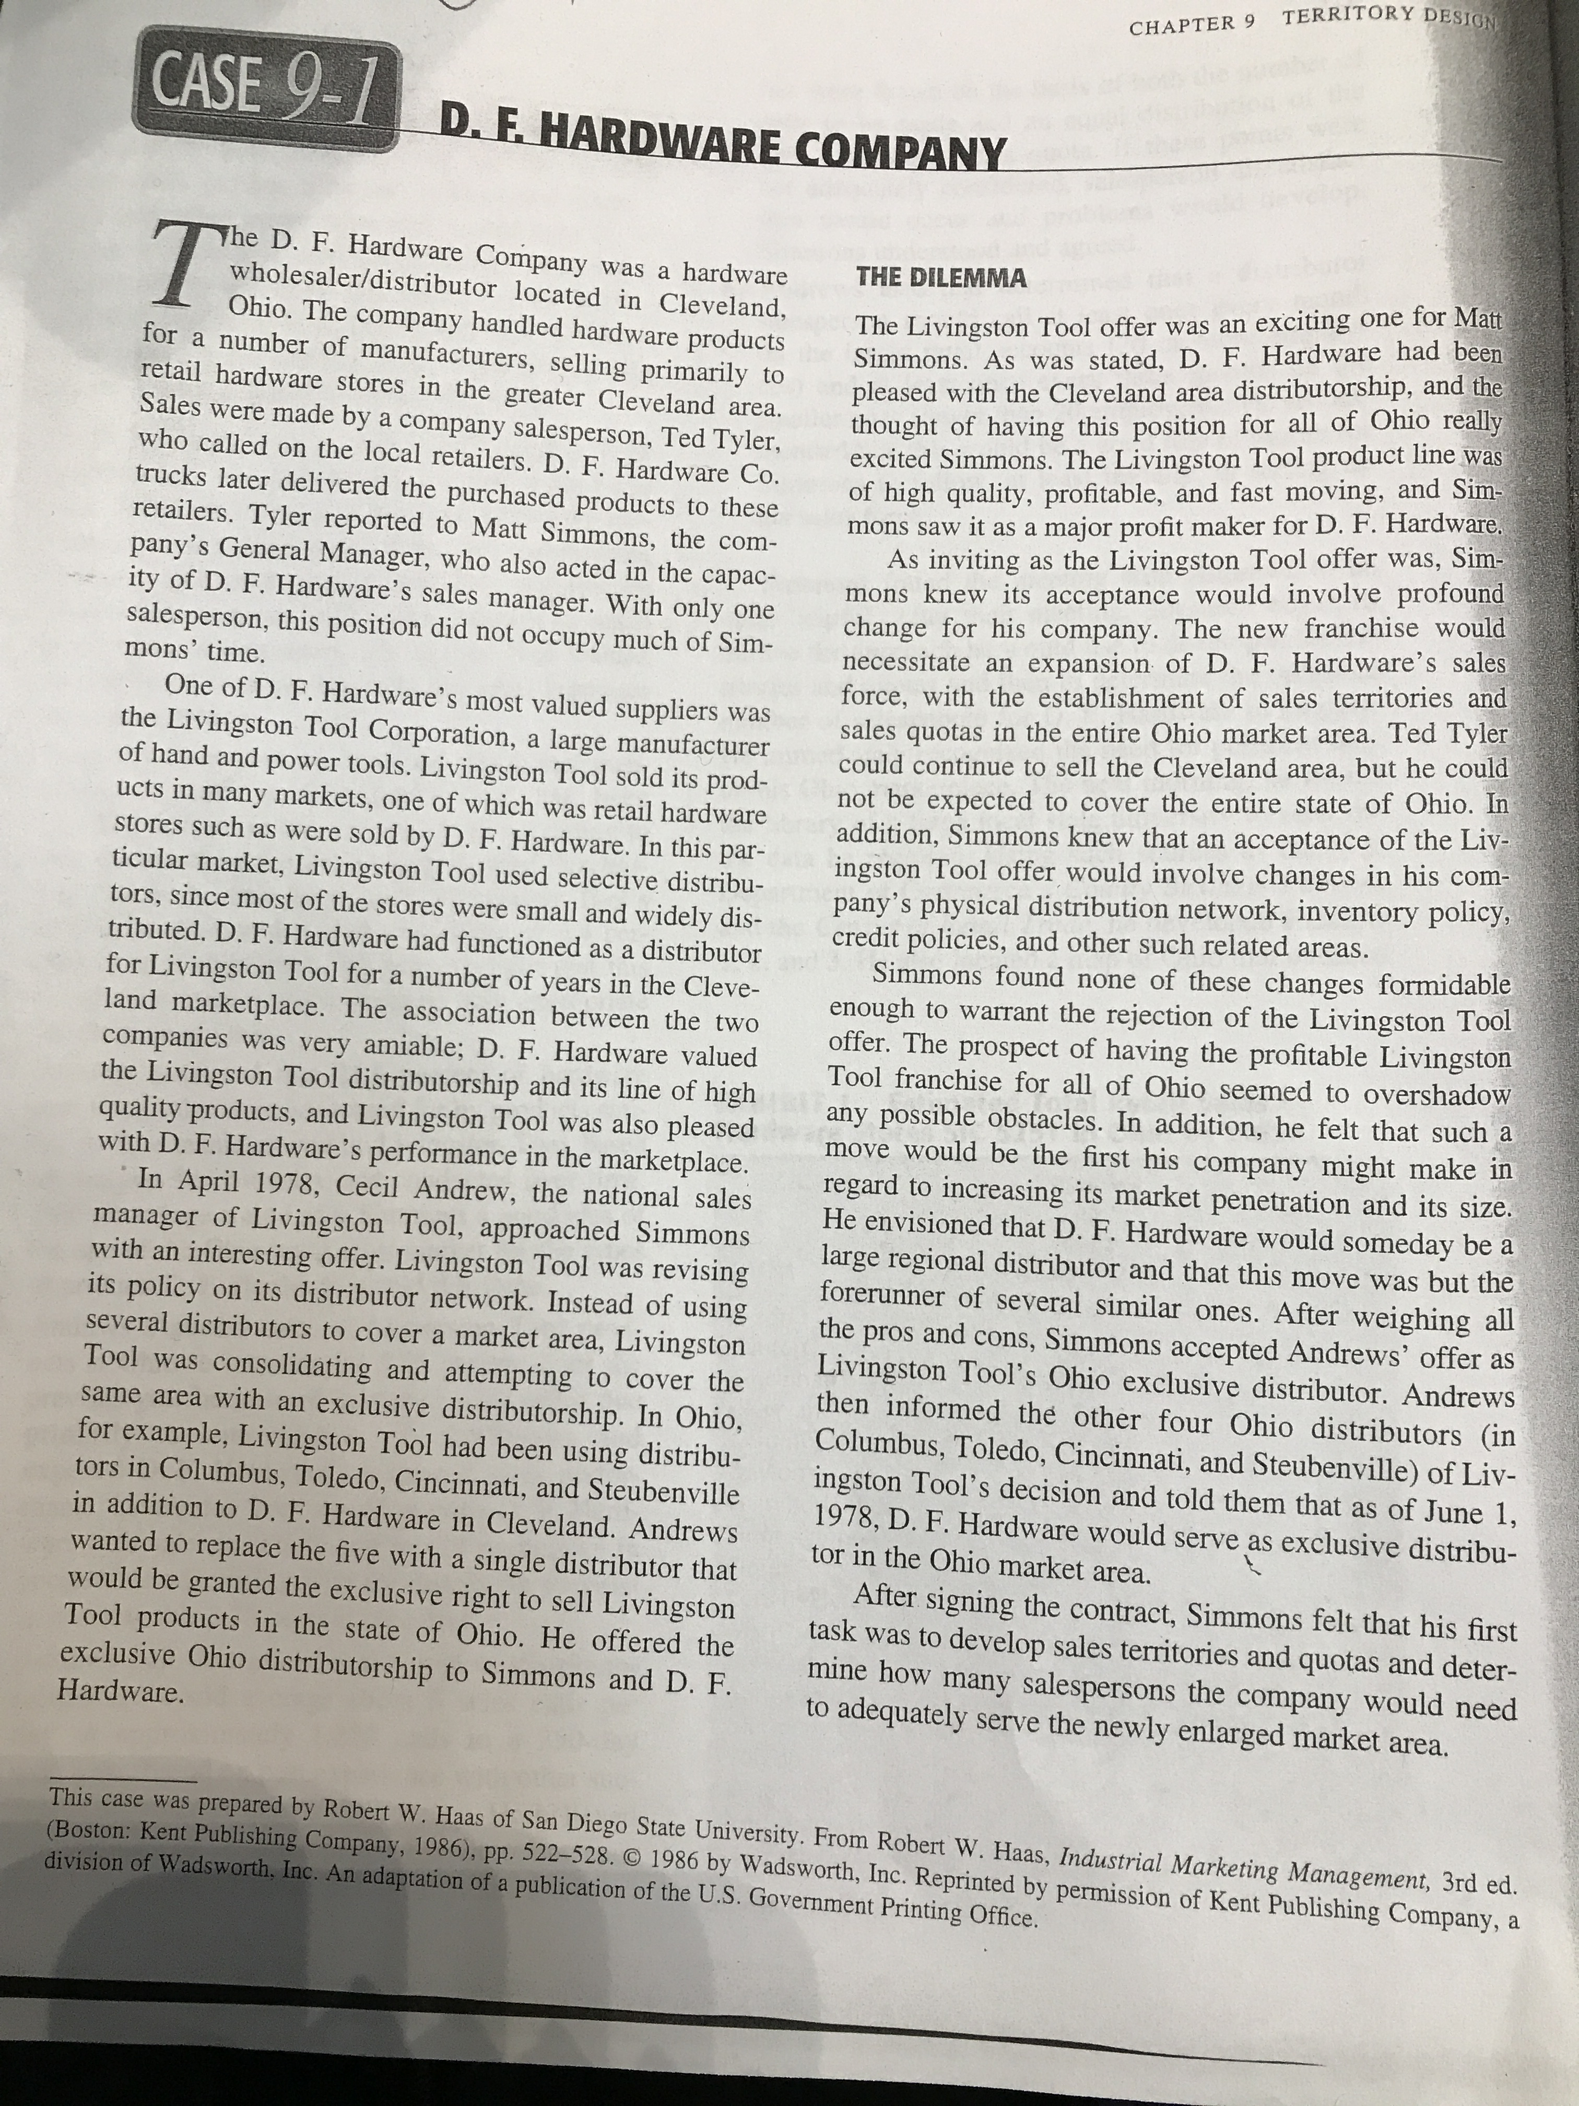
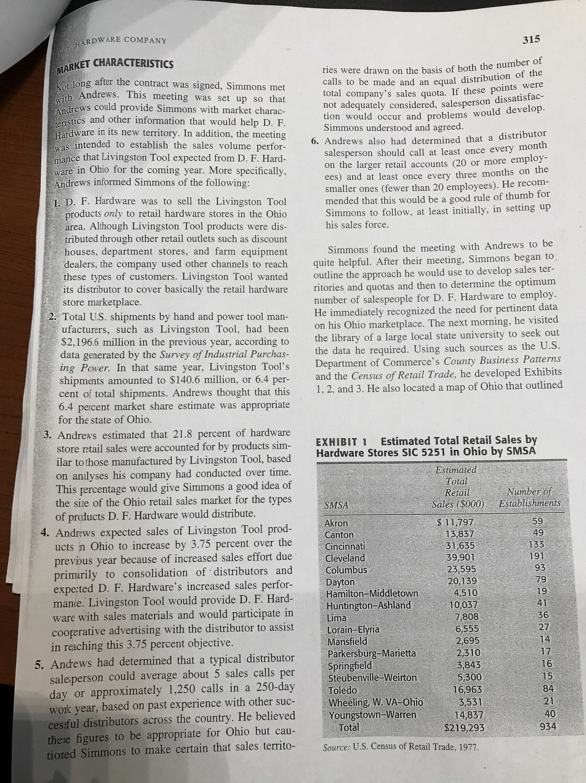

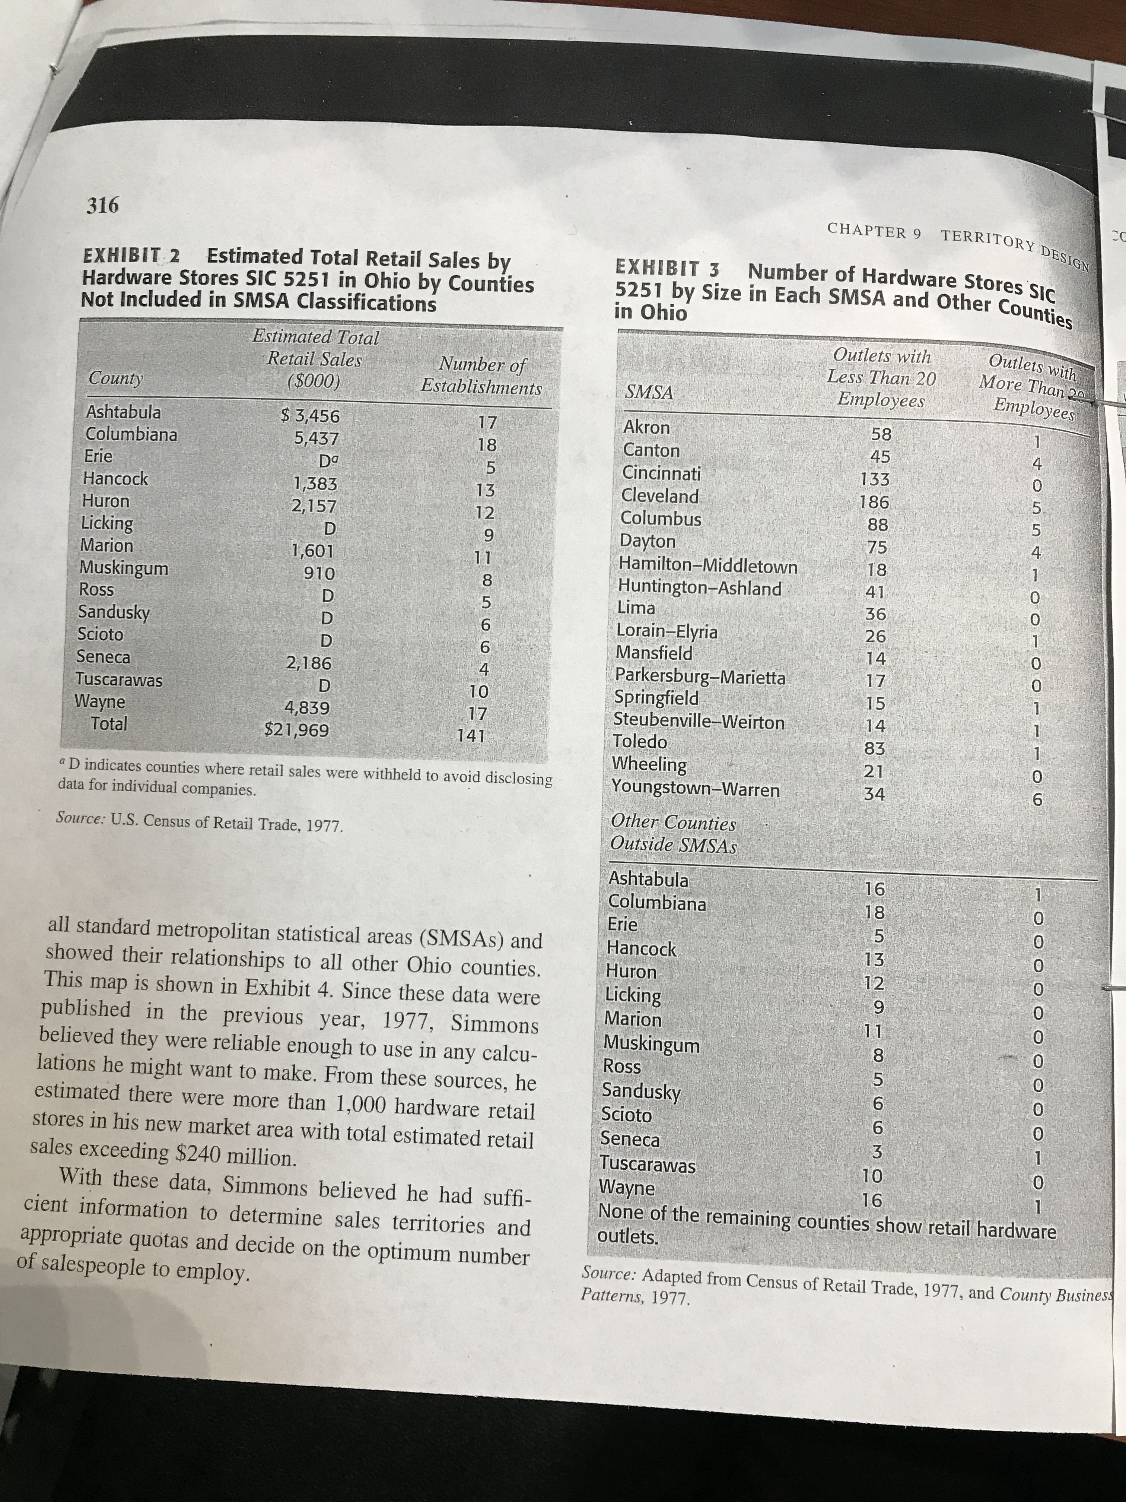

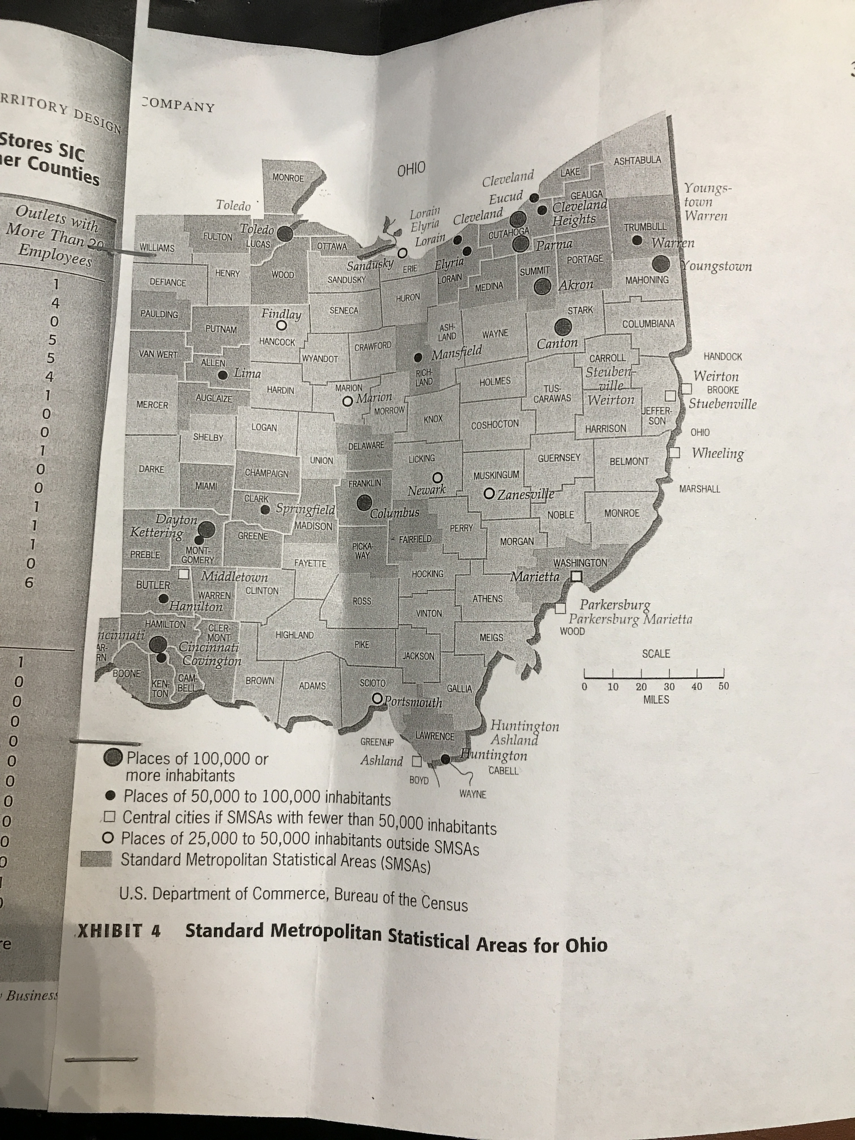

D.F Hardware Company Case Study

Major Case Analysis: This is also a team assignment and the cases assigned as much longer and
require a very detailed analysis and presentation. Assume the role of the decision maker as you
prepare for class discussion of the cases. Look for ways to use class and chapter concepts as you
prepare. Below is a suggested outline for writing up case analysis report. Following is a suggestion
and modifications to the suggested format can be made as needed. Typical report may
include the following components:
- Company Description: D.F Hardware company is a wholesaler/distributor located in cleveland, ohio who handles hardware products from a number of manufacturers who they sell to retail hardware stores.
- Statement of mission and goals – You will have to write up a mission statement based on your assessment of company profile.
- Situation Analysis – External and Internal factors have to be addressed well
- Statement of Objectives – prioritized as primary and secondary
- Strategic alternatives
- Evaluation of alternatives – Discussion of pros and cons of the listed alternatives
- Selection of strategic alternative and implementation
  - Statement of Selected strategy
  - Justification for selected strategy
- Specifics of the selected Program or tactics.
- Evaluation and control
Tables, charts, graphs, and computations can be placed in Appendix with sequential numbering of the attachments. All the attachments must be “referred to” in the write-up. Major case write up should be between 6 to 8 pages including graphs and charts.

Discussion Questions: This could be used for graphing
1)Based on Andrew’s ratios and percentages, estimate the sales potential for D.F Hardware for the coming year. Be sure to include Andres’ 3.75 percent expected increase in your calculations.
2) Assuming Andrews’ customer call frequencies to be valid, and that a salesperson should be able to make five calls per day, determine an optimum number of salespeople for Simmons to employ.
3) using exhibit 4 as a guide, determine the sales territories simmons should use in most effectively covering the Ohio Market area.
4) Determine sales quota figures for each of your defined territories.

